Is This Your Grandmother’s Fight? Black Women and the Politics of Respectability and Resistance

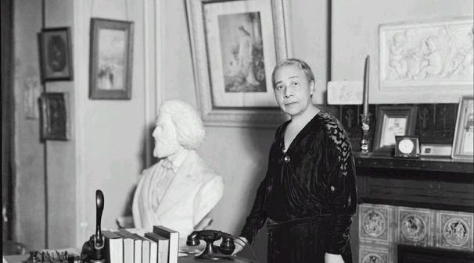

Welcome!
This curriculum is a resource for educators interested in teaching and learning about Anna Julia Cooper (August 10, 1858 – February 27, 1964): educator, sociologist, author, theorist and activist. The Colored Conventions Project Curriculum Team was created to provide a resource for educators to participate in the Frederick Douglass Day events planned by the Colored Conventions Project. This year the focus of our annual celebration on the life and legacy of Douglass will also center the work and life of Anna Julia Cooper. This curriculum explores Cooper and the ways she implemented and refined the use of the Politics of Respectability in her work for Black education, freedom and racial uplift.
Using the Paideia method, students will learn about the Cooper’s life and her work as an educator, activist and theorist. Her praxis (theories-in-practice) and contributions will serve as a lens through which to consider the concept of “Respectability Politics” as a tactic and methodology. Though widely used during the 1960s Civil Rights Movement, contemporary movements such as Black Lives Matter and others have critiqued Respectability Politics and/or complicated the utility or efficacy of this strategy.
Through this curriculum, students will learn how to identify and analyze Respectability Politics as a tactic, its use, limitations, adaptability and endurance in struggles for civil rights in America over time. Students will read, watch and discuss excerpts from: Anna Julia Cooper’s, Only the Black Woman can Say, Mary Helen Washington’s A Black Feminist Voice of the 1890s, Britney Cooper’s “Prologue” in Beyond Respectability, a formal portrait of Anna Julia Cooper and an edited video and the lyrics of Nina Simone’s Mississippi Goddam.
As a professional educator, you know your students, your school system, the standards and both school district specific expectations of the ways that content needs to be presented in your classroom. It is with this in mind, that this unit is offered as a resource. Please read and choose what you might want to use in your classroom in whatever format would work best. Feel free to modify, shape and tailor what is here to meet the demands and needs of your own pedagogy and context. But when you do, please do let us know.
We believe that the work of education is not just lifelong but a collective responsibility. It is in this spirit we offer this resource as a collaborative initiative, not bound by limitations of place or time. Email us at info@coloredconventions.org, contact us on Twitter or on our website. Let us know if you used the curriculum in its entirety, a single element or elements; what worked, what was most useful, what was not useful and or the ways you might have been inspired by what we offered and created your own lesson plans, units or classroom resources to celebrate Frederick Douglass, Anna Julia Cooper and or other notable African American people, places, events or time-periods. We look forward to hearing from you!
With anticipation,
Denise Burgher
Co-Chair, Colored Conventions Project Curriculum Team 2020

Table of Contents
Welcome--------------------------------------------------------------------------------------------------------page 1
Table of Contents---------------------------------------------------------------------------------------------page 2
Objective of Unit----------------------------------------------------------------------------------------------page 3
Materials Needed
Summative Assessment
Introduction----------------------------------------------------------------------------------------------------page 4
Framing and Connecting
Preparation
Pre-reading
Activity One—Respectability Politics-------------------------------------------------------------------page 5
Think—Pair—Share interview
Read and Discuss---Definition of Respectability Politics
Activity Two—The Power of Words ---------------------------------------------------------------------page 8
Definition Search
List of Key words, concepts with and without definitions
Activity Three—Legacy of a Life-------------------------------------------------------------------------page 17
Anna Julia Cooper, Read and Respond
Reading One Biography of Anna Julia Cooper
Activity Four—Respectability and Image -------------------------------------------------------------page 20
Analysis of formal portrait of Anna Julia Cooper
Activity Five—Anna Julia Cooper, Black Feminism and the Politics of Respectability---page 22
Read, Discuss and Report Back
Reading Two: Black Feminism
Reading Three: Beyond Respectability
Activity Six—Respectability Politics, Music and the Civil Rights Movement ---------------page 29
Reading Four: Music and the Civil Rights Movement
Reading Five: Nina Simone and Mississippi Goddamn
Reading Six: Mississippi Goddamn Lyrics
Summative Assessment Description—What Respectability Politics means to Me--------------------page 35
Template of Personal Letter
Model of Personal Letter
Extra Credit Respectability Politics in Philadelphia & DC in the Twenty-first Century----page 38
Photo Essay

Objective of Unit
Title: Is this your Grandmother’s Fight? Black Feminism and the Politics of Respectability and Resistance
Grade: Eleventh to Twelfth
Objective: Using the Paideia method, students will learn about the life and work of nineteenth century educator, activist and theorist Anna Julia Cooper. Her praxis (theories-in-practice) and contributions will serve as a lens through which to consider the concept of Respectability Politics as a tactic and methodology. Widely used during the 1960s Civil Rights Movement, contemporary movements such as Black Lives Matter and others have critiqued Respectability Politics and/or complicated the utility or efficacy of this strategy.
Through this curriculum, students will learn how to identify and analyze Respectability Politics as a tactic, its use, limitations and endurance in struggles for civil rights in America. Students will read, watch and discuss excerpts from the assigned readings: Anna Julia Cooper’s Only the Black Woman can Say, Mary Helen Washington’s A Black Feminist Voice of the 1890s, Britney Cooper’s “Prologue” in Beyond Respectability, video of and lyrics of Nina Simone’s Mississippi Goddam.
Materials Needed: Hard or soft copies of readings—the list of assigned texts, access to a projector and screen and access to internet to stream and exhibit a video. Students must have access to computers or writing utensils and notebooks and access to internet enabled devices for research(limited).
Summative Assessment: Students will write a personal letter to Anna Julia Cooper explaining how Respectability Politics has evolved from the nineteenth to the twenty-first century. Grounded in their own experiences and observations, students will use details from their research in one contemporary art form, classroom discussions, readings and videos as their source materials.
The letter shall be 800 to 1000 words, written in the first person, and demonstrate knowledge of the concepts, key words and relevant vocabulary.

Introduction: Introduce students to the topic, Black Feminism and the Politics of Respectability and Resistance. Explain that we will be learning about Anna Julia Cooper, her life, work and her deployment of Respectability Politics. Ask if anyone knows what Respectability Politics is or what they believe the term might mean. Take all responses. Optional: Distribute copies of the definition by Paisley Harris on pages 6-7. Invite students to read and practice marginalia while by underlining, starring circling, making notes in the margins. Discuss. Take all responses.

Framing and Connecting: Explain to your students that we will be exploring and learning the concept of Respectability Politics. Because Respectability Politics is grounded in the nineteenth century and, more significantly, in the intellectual and organizing labor of Black women from that time period, we will consider the work of Black women theorists, historians and activists as we learn about the life and legacy of Anna Julia Cooper. Optional: Ask students if they are familiar with the term Respectability Politics, where have they heard it and if so, how was it being used? There have been memes, TikTok videos and slogans which have engaged in a critique of Respectability Politics. Have students seen or noticed this ongoing dialogue, what are their thoughts?

Preparation
Pre-reading: Students will use their computers or telephones to look up the following list of keywords and come to class with a complete/partial list of the following words with definitions written in their own words. They will match the words to the definitions in a warm-up. See Figure one for the list of words, Figure two for the list of key words and concepts with selected definitions and Figure three for the definitions only which need to be matched with the key words and or concepts.

Activity One: Project on a screen or distribute individual copies of the Anna Julia Cooper excerpt, “When and where I enter.” Below the excerpt, please print or display the three questions that follow and direct them to write written responses to the questions in their notebooks.
When and Where I enter: Excerpted from Only the Black Woman Can Say: “When and where I enter,” by Anna Julia Cooper
Only the Black Woman can say "when and where I enter, in the quiet, undisputed dignity of my womanhood, without violence and without suing or special patronage, then and there the whole Negro race enters with me." Is it not evident then that as individual workers for this race we must address ourselves with no half-hearted zeal to this feature of our mission. The need is felt and must be recognized by all. There is a call for workers, for missionaries, for men and women with the double consecration of a fundamental love of humanity and a desire for its melioration through the Gospel; but superadded to this we demand an intelligent and sympathetic comprehension of the interests and special needs of the Negro.
Anna Julia Cooper, excerpted from Only the Black Woman Can Say
- What does Cooper mean when she said, “the whole race enters with me”? Who is she suggesting is not as capable to represent the race and why?
- Considering the list of “jobs” which Cooper includes in the section and the qualities she identified, what kind of work was she expecting these workers to accomplish?
- How would they fight oppression and what would that look like?

Read, Discuss and Summarize
Direct students to read the paragraph by Paisley Harris—popcorn reading, or other active reading technique. Discuss what the students understand about the concept, Politics of Respectability and write a five-sentence summary in their notebooks describing what they think the term Respectability Politics means.
Respectability Politics
Excerpted from “Gatekeeping and Remaking: The Politics of Respectability in African American Women's History and Black Feminism” by Paisley Harris.
In Righteous Discontent: The Women's Movement in the Black Baptist Church, 1880-1920, Evelyn Brooks Higginbotham first coined the term "politics of respectability" to describe the work of the Women's Convention of the Black Baptist Church during the Progressive Era. She specifically referred to African American's promotion of temperance, cleanliness of person and property, thrift, polite manners, and sexual purity. The politics of respectability entailed "reform of individual behavior as a goal in itself and as a strategy for reform." Respectability was part of "uplift politics," and had two audiences: African Americans, who were encouraged to be respectable, and white people, who needed to be shown that African Americans could be respectable. ¹
African American women were particularly likely to use respectability and to be judged by it. Moreover, African American women symbolized, even embodied, this concept. Respectability became an issue at the juncture of public and private. It thus became increasingly important as both Black and white women entered public spaces. ²
Since the publication of Righteous Discontent, exploring the politics of respectability has enriched scholars' understandings of Black reformism and intra-racial class politics.³ The prevailing interpretation suggests that the politics of respectability undermined the rigidly scientific nature of racial categories, but generally tended to reinforce status distinctions within the African American community. These distinctions were about class, but they were defined primarily in behavioral, not economic, terms. By linking worthiness for respect to sexual propriety, behavioral decorum, and neatness, respectability served a gatekeeping function, establishing a behavioral "entrance fee," to the right to respect and the right to full citizenship.

Harris, Paisley. (2003). Gatekeeping and Remaking: The Politics of Respectability in African American Women's History and Black Feminism. Journal of Women's History. 15. 212-220. 10.1353/jowh.2003.0025.

Activity Two
Definition Search
Students will find the definitions of these words. Please remind them not stop with Wikipedia, but to start there. Look at the sources in the Wikipedia articles for the terms, click on and follow the links so that you can read who said what and why. Can identify what made it into the Wikipedia article and what did not?
List of Key Words and Terms

- Respectability Politics

- Racial uplift

- Black Feminism

- Feminism

- Radical Feminism

- Resistance

- Black Lives Matter

- Civil Rights Movement

- Non-violence

- Social Justice

- White Supremacy

- Domestic terrorism

- Praxis

- Strategy

- Tactic

- Dignity

- Activist

- Theorist

- Critique

- Teach-in

- Intersectional

List of Key Words & Definitions
Respectability Politics: The politics of respectability practiced during the nineteenth century entailed "reform of individual behavior as a goal in itself and as a strategy for reform." Respectability was part of "uplift politics," and had two audiences: African Americans, who were encouraged to be respectable, and white people, who needed to be shown that African Americans could be respectable.
Racial uplift: In response to violent racism in the twentieth century, upper class African Americans, struggling to express and represent a positive Black identity, developed a middle-class ideology of racial uplift. They insisted that they—educated, refined, professionals, middle to upper class and often light of skin, were truly representative of the race's potential. Black elites championed self-help and service to the Black masses—education, athletic clubs, jobs training and distinguished themselves from the Black majority as agents of civilization; hence the phrase 'uplifting the race. A central assumption of racial uplift ideology was that African Americans' material and moral progress would diminish white racism—which was the goal. Racial uplift had three audiences: Black upper class, Black masses and the white broader society. Ultimately, elite conceptions of the ideology retreated from more democratic visions of uplift as social advancement, leaving a legacy that narrows our conceptions of rights, citizenship, and social justice. https://uncpress.org/book/9780807845431/uplifting-the-race/
Black Feminism: (is) actively committed to struggling against racial, sexual, heterosexual, and class oppression, and see as our particular task the development of integrated analysis and practice based upon the fact that the major systems of oppression are interlocking. The synthesis of these oppressions creates the conditions of our lives. As Black women we see Black feminism as the logical political movement to combat the manifold and simultaneous oppression that all women of color face. It was important for Black feminism to address the ways that racism, sexism, classism and heterosexism all worked to perpetuate each other. In these two definitions of Black feminism/womanism, one can see the complementary nature of one's personal life in relation to one's political life. From the personal, the striving toward wholeness individually and within the community, comes the political, the struggle against those forces that render individuals and communities unwhole. The personal is political, especially for Black women. Black feminist writings were to focus on developing theory which would address the simultaneity of racism, sexism, heterosexism, and classism in their lives. In addition, the audience of these writings was to be Black women, rather than white feminists or Black male activists. As mentioned earlier, to continue to address the oppressor's needs would be a waste of valuable energy. Black women needed to develop a critical, feminist consciousness and begin a dialogue which directly addressed their experiences and connected them to a larger political system. https://www.mit.edu/activities/thistle/v9/9.01/6blackf.html

Feminism: Many organized social, political, cultural, movements and ideologies working to define, establish, and achieve political, economic, personal, and social equality of the sexes.
Black Lives Matter: A political movement to address systemic and state violence against African Americans. Per the Black Lives Matter organizers: “In 2013, three radical Black organizers—Alicia Garza, Patrisse Cullors, and Opal Tometi—created a Black-centered political will and movement building project called #BlackLivesMatter. It was in response to the acquittal of Trayvon Martin’s murderer, George Zimmerman. The project is now a member-led global network of more than 40 chapters. [Black Lives Matter] members organize and build local power to intervene in violence inflicted on Black communities by the state and vigilantes. Black Lives Matter is an ideological and political intervention in a world where Black lives are systematically and intentionally targeted for demise. It is an affirmation of Black folks’ humanity, our contributions to this society, and our resilience in the face of deadly oppression.” Black Lives Matter, “Herstory”, accessed 10/7/19
Intersectional: Exposing [one’s] multiple identities can help clarify they ways in which a person can simultaneously experience privilege and oppression. For example, a Black woman in America does not experience gender inequalities in exactly the same way as a white woman, nor racial oppression identical to that experienced by a Black man. Each race and gender intersection produce a qualitatively distinct life. Intersectionality is simply a prism to see the interactive effects of various forms of discrimination and disempowerment. It looks at the way that racism, many times, interacts with patriarchy, heterosexism, classism, xenophobia—seeing that the overlapping vulnerabilities created by these systems actually create specific kinds of challenges. “Intersectionality 102,” then, is to say that these distinct problems create challenges for movements that are only organized around these problems as separate and individual. So, when racial justice doesn’t have a critique of patriarchy and homophobia, the particular way that racism is experienced and exacerbated by heterosexism, classism etc., falls outside of our political organizing. It means that significant numbers of people in our communities aren’t being served by social justice frames because they don’t address the particular ways that they’re experiencing discrimination. 1. Intergroup Resources, 2012 2. Kimberle Crenshaw https://www.them.us/story/kimberle-crenshaw-lady-phyll-intersectionality
Civil Rights Movement: During the 1950’s and 1960’s, in response to the continued and intensified widespread segregation, discrimination, disenfranchisement and racially motivated violence that permeated all personal and structural aspects of life for Black people, masses of people organized to reverse, and bring to an end racial discrimination and injustice. “Jim Crow” laws at local and state levels barred African Americans from classrooms and bathrooms, from theaters and train cars, from juries and legislatures. Activists worked together and used non-violent protest and specific acts of targeted civil disobedience, such as the Montgomery Bus Boycott and the Greensboro Woolworth Sit-Ins, in order to bring about change. Much of this organizing and activism took place in the Southern part of the United States; however, people from all over the country—of all races and religions—joined activists to proclaim their support and commitment to freedom and equality.
https://www.adl.org/education/resources/backgrounders/civil-rights-movement

Non-violence: Martin Luther King’s notion of nonviolence had six key principles. First, one can resist evil without resorting to violence. Second, nonviolence seeks to win the “friendship and understanding” of the opponent, not to humiliate him (King, Stride, 84). Third, evil itself, not the people committing evil acts, should be opposed. Fourth, those committed to nonviolence must be willing to suffer without retaliation as suffering itself can be redemptive. Fifth, nonviolent resistance avoids “external physical violence” and “internal violence of spirit” as well: “The nonviolent resister not only refuses to shoot his opponent, but he also refuses to hate him” (King, Stride, 85). The resister should be motivated by love in the sense of the Greek word agape, which means “understanding,” or “redeeming good will for all men” (King, Stride, 86). The sixth principle is that the nonviolent resister must have a “deep faith in the future,” stemming from the conviction that “The universe is on the side of justice.” King, Martin Luther. Stride Toward Freedom, page 88.
Social Justice: Social Justice as a concept arose in the early 19th century during the Industrial Revolution and subsequent civil revolutions throughout Europe, which aimed to create more equal societies and stop exploitation of human labor. Because of the extreme differences between the wealthy and the poor during this time, early social justice advocates focused primarily on capital, property, and the distribution of wealth. By the mid-20th century, social justice had expanded from being primarily concerned with economics to include other spheres of social life: the environment, race, gender, and other causes and manifestations of inequality.
https://www.pachamama.org/social-justice/what-is-social-justice
White Supremacy: White Supremacy is a historically based, institutionally perpetuated system of exploitation and oppression of continents, nations and peoples of color by white peoples and nations of the European continent; for the purpose of maintaining and defending a system of wealth, power and privilege. 1. White Supremacy Culture refers to the dominant, unquestioned standards of behavior and ways of functioning embodied by the vast majority of institutions in the United States. These standards may be seen as mainstream, dominant cultural practices; they have evolved from the United States’ history of white supremacy. Because it is so normalized it can be hard to see, which only adds to its powerful hold. In many ways, it is indistinguishable from what we might call U.S. culture or norms – a focus on individuals over groups, for example, or an emphasis on the written word as a form of professional communication. But it operates in even more subtle ways, by actually defining what “normal” is – and likewise, what “professional,” “effective,” or even “good” is. In turn, white culture also defines what is not good, “at risk,” or “unsustainable.” White culture values some ways – ways that are more familiar and come more naturally to those from a white, western tradition – of thinking, behaving, deciding, and knowing, while devaluing or rendering invisible other ways. And it does this without ever having to explicitly say so.
2. White supremacy culture is an artificial, historically constructed culture which expresses, justifies and binds together the United States white supremacy system. It is the glue that binds together white-controlled institutions into systems and white-controlled systems into the global white supremacy system.
1. Paying Attention to White Culture and Privilege: A Missing Link to Advancing Racial Equity, by Gita Gulati- Partee and Maggie Potapchuk, The Foundation Review, Vol. 6: Issue 1 (2014).
2. Challenging White Supremacy Workshop, Sharon Martinas Fourth Revision. 1995.

Figure three
List of Definitions without Identifying Concepts or Terms (for matching exercise)
Students will write the correct term or keyword above each definition. (Seat work or group work) Self-check. Discuss.

During the 1950’s and 1960’s in response to the continued and intensified widespread segregation, discrimination, disenfranchisement and racially motivated violence that permeated all personal and structural aspects of life for Black people, mases of people organized to reverse, and bring to an end racial discrimination and injustice. “Jim Crow” laws at local and state levels barred African Americans from classrooms and bathrooms, from theaters and train cars, from juries and legislatures. Activists worked together and used non-violent protest and specific acts of targeted civil disobedience, such as the Montgomery Bus Boycott and the Greensboro Woolworth Sit-Ins, in order to bring about change. Much of this organizing and activism took place in the Southern part of the United States; however, people from all over the country—of all races and religions—joined activists to proclaim their support and commitment to freedom and equality.
https://www.adl.org/education/resources/backgrounders/civil-rights-movement

(is) actively committed to struggling against racial, sexual, heterosexual, and class oppression, and see as our particular task the development of integrated analysis and practice based upon the fact that the major systems of oppression are interlocking. The synthesis of these oppressions creates the conditions of our lives. As Black women we see Black feminism as the logical political movement to combat the manifold and simultaneous oppression that all women of color face. It was important for Black feminism to address the ways that racism, sexism, classism and heterosexism all worked to perpetuate each other. In these two definitions of Black feminism/womanism, one can see the complementary nature of one's personal life in relation to one's political life. From the personal, the striving toward wholeness individually and within the community, comes the political, the struggle against those forces that render individuals and communities unwhole. The personal is political, especially for Black women. Black feminist writings were to focus on developing theory which would address the simultaneity of racism, sexism, heterosexism, and classism in their lives. In addition, the audience of these writings was to be Black women, rather than white feminists or Black male activists. As mentioned earlier, to continue to address the oppressor's needs would be a waste of valuable energy. Black women needed to develop a critical, feminist consciousness and begin a dialogue which directly addressed their experiences and connected them to a larger political system. https://www.mit.edu/activities/thistle/v9/9.01/6blackf.html

many organized social, political, cultural, movements and ideologies working to define, establish, and achieve political, economic, personal, and social equality of the sexes.
A political movement to address systemic and state violence against African Americans. Per the Black Lives Matter organizers: “In 2013, three radical Black organizers—Alicia Garza, Patrisse Cullors, and Opal Tometi—created a Black-centered political will and movement building project called #BlackLivesMatter. It was in response to the acquittal of Trayvon Martin’s murderer, George Zimmerman. The project is now a member-led global network of more than 40 chapters. [Black Lives Matter] members organize and build local power to intervene in violence inflicted on Black communities by the state and vigilantes. Black Lives Matter is an ideological and political intervention in a world where Black lives are systematically and intentionally targeted for demise. It is an affirmation of Black folks’ humanity, our contributions to this society, and our resilience in the face of deadly oppression.” Black Lives Matter, “Herstory”, accessed 10/7/19
practiced during the nineteenth century entailed "reform of individual behavior as a goal in itself and as a strategy for reform." Respectability was part of "uplift politics," and had two audiences: African Americans, who were encouraged to be respectable, and white people, who needed to be shown that African Americans could be respectable.
In response to violent racism in the twentieth century, upper class African Americans, struggling to express and represent a positive Black identity, developed a middle-class ideology of racial uplift. They insisted that they—educated, refined, professionals, middle to upper class and often light of skin, were truly representative of the race's potential. Black elites championed self-help and service to the Black masses—education, athletic clubs, jobs training and distinguished themselves from the Black majority as agents of civilization; hence the phrase “uplifting the race.” A central assumption of racial uplift ideology was that African Americans' material and moral progress would diminish white racism—which was the goal. Racial uplift had three audiences-Black upper class, Black masses and the white broader society. Ultimately, elite conceptions of the ideology retreated from more democratic visions of uplift as social advancement, leaving a legacy that narrows our conceptions of rights, citizenship, and social justice. https://uncpress.org/book/9780807845431/uplifting-the-race/
Martin Luther King’s notion of nonviolence had six key principles. First, one can resist evil without resorting to violence. Second, nonviolence seeks to win the “friendship and understanding” of the opponent, not to humiliate him (King, Stride, 84). Third, evil itself, not the people committing evil acts, should be opposed. Fourth, those committed to nonviolence must be willing to suffer without retaliation as suffering itself can be redemptive. Fifth, nonviolent resistance avoids “external physical violence” and “internal violence of spirit” as well: “The nonviolent resister not only refuses to shoot his opponent, but he also refuses to hate him” (King, Stride, 85). The resister should be motivated by love in the sense of the Greek word agape, which means “understanding,” or “redeeming good will for all men” (King, Stride, 86). The sixth principle is that the nonviolent resister must have a “deep faith in the future,” stemming from the conviction that “The universe is on the side of justice.”
King, Martin Luther. Stride Toward Freedom, page 88.

Exposing [one’s] multiple identities can help clarify they ways in which a person can simultaneously experience privilege and oppression. For example, a Black woman in America does not experience gender inequalities in exactly the same way as a white woman, nor racial oppression identical to that experienced by a Black man. Each race and gender intersection produce a qualitatively distinct life. Intersectionality is simply a prism to see the interactive effects of various forms of discrimination and disempowerment. It looks at the way that racism, many times, interacts with patriarchy, heterosexism, classism, xenophobia—seeing that the overlapping vulnerabilities created by these systems actually create specific kinds of challenges. “Intersectionality 102,” then, is to say that these distinct problems create challenges for movements that are only organized around these problems as separate and individual. So, when racial justice doesn’t have a critique of patriarchy and homophobia, the particular way that racism is experienced and exacerbated by heterosexism, classism etc., falls outside of our political organizing. It means that significant numbers of people in our communities aren’t being served by social justice frames because they don’t address the particular ways that they’re experiencing discrimination. 1. Intergroup Resources, 2012 2. Kimberle Crenshaw https://www.them.us/story/kimberle-crenshaw-lady-phyll-intersectionality

a historically based, institutionally perpetuated system of exploitation and oppression of continents, nations and peoples of color by white peoples and nations of the European continent; for the purpose of maintaining and defending a system of wealth, power and privilege. 1. Culture refers to the dominant, unquestioned standards of behavior and ways of functioning embodied by the vast majority of institutions in the United States. These standards may be seen as mainstream, dominant cultural practices; they have evolved from the United States’ history of white supremacy. Because it is so normalized it can be hard to see, which only adds to its powerful hold. In many ways, it is indistinguishable from what we might call U.S. culture or norms – a focus on individuals over groups, for example, or an emphasis on the written word as a form of professional communication. But it operates in even more subtle ways, by actually defining what “normal” is – and likewise, what “professional,” “effective,” or even “good” is. In turn, white culture also defines what is not good, “at risk,” or “unsustainable.” White culture values some ways – ways that are more familiar and come more naturally to those from a white, western tradition – of thinking, behaving, deciding, and knowing, while devaluing or rendering invisible other ways. And it does this without ever having to explicitly say so.
2. culture is an artificial, historically constructed culture which expresses, justifies and binds together the United States white supremacy system. It is the glue that binds together white-controlled institutions into systems and white-controlled systems into the global white supremacy system.
1. Paying Attention to White Culture and Privilege: A Missing Link to Advancing Racial Equity, by Gita Gulati- Partee and Maggie Potapchuk, The Foundation Review, Vol. 6: Issue 1 (2014).
2. Challenging White Supremacy Workshop, Sharon Martinas Fourth Revision. 1995.

as a concept arose in the early 19th century during the Industrial Revolution and subsequent civil revolutions throughout Europe, which aimed to create more equal societies and stop exploitation of human labor. Because of the extreme differences between the wealthy and the poor during this time, early social justice advocates focused primarily on capital, property, and the distribution of wealth. By the mid-20th century, social justice had expanded from being primarily concerned with economics to include other spheres of social life: the environment, race, gender, and other causes and manifestations of inequality. https://www.pachamama.org/social-justice/what-is-social-justice

Activity Three: Legacy of a Life
All students will read the biographical text (Reading One) on Anna Julia Cooper and will answer the following questions in complete sentences in their notebooks:
- Identify the first feminist stand which Cooper took. Where did this take place and why was it so important?
- How did Cooper change the curriculum at the M Street School? And what were the results?
- What was Cooper’s passion and how did she demonstrate her beliefs?

Reading One

A Biography of Anna Julia Cooper (August 10, 1858 – February 27, 1964)

Excerpted from:

When and Where I Enter: Anna Julia Cooper, Afrocentric Theory, and Africana Studies by LaRese C. Hubbard Journal of Black Studies Vol. 40, No. 2 (Nov., 2009), pp. 283-295
Cooper, Anna Julia. By Ansley Wegner, Research Branch, NC Office of Archives and History, 2010 www.ncmarkers.com.Downloaded December 5th, 2019
Biography of Anna Julia Cooper by Dr. Shirley Moody Turner for Frederick Douglass Day 2020

Dr. Anna Julia Cooper was an educational leader, feminist, and advocate for the rights of all African Americans, particularly Black women, in the late nineteenth century and early twentieth century. She educated all United States citizens about sexism and racism through her writing, speeches, and decades of community service.
Cooper was born in Raleigh, North Carolina. Cooper was the daughter of Hannah Stanley, an enslaved person of the Haywood family. She had two older brothers, Andrew and Rufus. Although she was born before President Abraham Lincoln issued the Emancipation Proclamation, Cooper had no memories of her life as a slave. Hannah Stanley taught Anna the importance of using her “voice” to support her family and the Black community.
In 1867, the Episcopal Church and Freedman’s Bureau built St. Augustine’s Normal School and Collegiate Institute on land owned by the Haywood family. St. Augustine’s educated freed slaves and their families. In 1868, Cooper received a scholarship to become one of the school’s first students. At St. Augustine’s, Cooper developed a love for learning that would stay with her the rest of her life. When Cooper was very young, she decided that she wanted to be a teacher who encouraged all children to learn. Cooper earned part of her tuition by tutoring her classmates.
St. Augustine’s focused on preparing its male students for the ministry of higher education. Because the administrators believed that women went to school to find a husband, female students could only take a series of basic classes known as the Ladies’ Course. This frustrated Anna, who longed for more challenging studies. “I constantly felt . . . a thumping from within unanswered by any beckoning from without,” she later said. She decided to raise her “voice” to fight for the right to take the same classes as the men.
While at St. Augustine’s, Anna took a Greek class taught by George A.C. Cooper, a formerly enslaved person who was studying to become a minister. The two fell in love and were married on June 21, 1877, after Anna finished her studies at St. Augustine’s. On September 27, 1879, just two months after becoming the second Black ordained minister in North Carolina’s Protestant Episcopal Church, George suddenly died. Anna said he died from working too hard. She never remarried.
In 1881, Mrs. Cooper started attending Ohio’s Oberlin College, one of the first co-educational institutions to admit both women and African Americans. She wrote letters to the school’s president for free tuition and a job so she could afford room and board. Among her classmates were Mary Eliza Church (Terrell) and Ida A. Gibbs (Hunt), future Black leaders. All three women took classes in Latin, Greek, modern European languages, literature, philosophy, science, and mathematics.
After graduating with a bachelor’s degree in mathematics in 1884, Mrs. Cooper taught Greek, French literature, and science at Wilberforce University, a historically Black school in Xenia, Ohio. Because she wanted to live closer to her mother, she returned to teach at St. Augustine’s in 1885. Two years later, Oberlin awarded her an honorary master’s degree.
In 1887, Mrs. Cooper was recruited to teach math and science at the Preparatory High School for Colored Youth in Washington, D.C., the nation’s largest high school for African Americans. This school was later known as M Street and today as Paul Laurence Dunbar High School. On January 1, 1902, Mrs. Cooper became the principal of M Street High School. She set high academic standards, hired capable teachers, and offered tutoring. She helped students believe that, regardless of their race or gender, they could achieve their dreams. While Mrs. Cooper was principal, many students at M Street earned scholarships to study at important institutions such as Harvard, Brown, Oberlin, Yale, Amherst, Dartmouth, and Radcliffe.
During this period, many Americans believed that Blacks weren’t as smart as whites. Mrs. Cooper, W.E.B. Du Bois, and Booker T. Washington believed differently. Mr. Washington thought Black students should take vocational education courses and work their way up through society starting as manual laborers. Mr. Du Bois believed that Blacks should study the classics and become community leaders. Because Mrs. Cooper agreed with both men, she offered courses in the liberal arts plus vocational and industrial education. Because the D.C. Board of Education preferred Mr. Washington’s methods, it did not renew Mrs. Cooper’s contract. She stopped being a principal in June 1906. Then she taught languages at the Lincoln Institute in Jefferson City, Missouri, until 1910, when she was rehired to teach Latin at M Street High School.
In 1914, Mrs. Cooper started working on her doctorate at Columbia University in New York City. On December 25, 1915, she became the guardian of five orphaned great-nieces and nephews ranging in age from 6 months to 12 years. Because of her teaching and family responsibilities, she was unable to go to Columbia full time to finish her degree, so she enrolled at the University of Paris, Sorbonne. On March 23, 1925, Mrs. Cooper earned her Ph.D. She was the fourth African-American woman to hold a doctorate. On December 29, 1925, D.C. Commissioner William Tindall awarded her degree in a special ceremony at Howard University.
On June 15, 1930, Dr. Cooper retired from M Street High School. She became president of Frelinghuysen University, which provided social services, vocational training, and educational programs for Black, working-class adults in Washington, D.C. She also established the Hannah Stanley Haywood Opportunity School in honor of her mother. When Frelinghuysen lost its building in 1931, Dr. Cooper let the school use her home at 201 T Street. She didn’t charge rent or accept a salary. In 1940, Dr. Cooper resigned as president but continued to work as the school’s registrar. She made arrangements for her home to be used to promote Black education after her death.

Activity Four: Respectability and Image
Students will receive a portrait of Anna Julia Cooper. Students will analyze and discuss the portrait. See portrait below. Suggested questions to explore:
- What is the tone of the image?
- The importance of the angle of the face, the adornment, props and her hairstyle?
- How are we to interpret this representation of a Black woman in the nineteenth century?
- What does Anna Julia Cooper want us to understand about who she is and why?
- Is Anna Julia Cooper engaging in the politics of respectability in this image and if so, how do we know? Why?
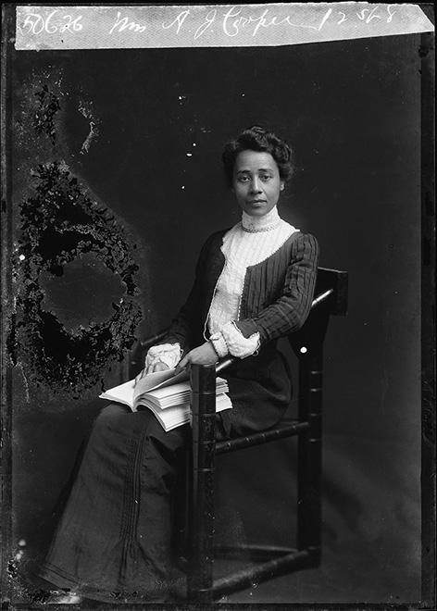
Portrait of Anna Julia Cooper (1858–1964), between 1901 and 1903. C. M. Bell Collection, Prints and Photographs Division, Library of Congress
https://www.loc.gov/exhibitions/women-fight-for-the-vote/about-this-exhibition/more-to-the-movement/anna-julia-cooper/

Anna Julia Cooper, Black Feminism and the Politics of Respectability

Activity Five: Anna Julia Cooper, Black Feminism and the Politics of Respectability
- Students will be divided into two groups. Each group will have one of the readings–either Reading Two or Reading Three–assigned to them. Each group will read and discuss their reading in a separate area of the classroom. Students will return to the regular class formation and share a brief summary of the text they read and discuss as a large group. See below for questions that can frame the conversations in the groups.
- Which text was the hardest to understand? Why? Give specific examples.
- How would you explain the history of Respectability Politics to your best friend who does not attend this school?
- What does Respectability Politics have to with the declaration, “I am not my ancestors, you can catch these hands!”

Reading Two
Anna Julia Cooper: The Black Feminist Voice of the 1890s
Author: Mary Helen Washington. Source: Legacy, Vol. 4, No. 2 (Fall 1987), pp. 3-15, University of Nebraska Press. Stable URL: https://www.jstor.org/stable/25678996 Accessed: 03-11-2019 15:19 UTC
Given Anna Julia Cooper’s unparalleled articulation of Black feminist thoughts in her major work A Voice from the South by a Black Woman of the South, published in 1892; given her role as a leading Black spokeswoman of her time (she was one of three Black women invited to address the World’s Congress of Representative in 1893 and one of the few women to speak at the 1900 Pan-African Congress Conference in London); given her leadership in women's organizations (she helped start the Colored YWCA in 1905 because of the Jim Crow policies of the white YWCA and in 1912 founded the first chapter of the Y's Camp Fire Girls); and given the fact that her work in educating Black students spanned nearly half a century, why is Anna Cooper a neglected figure, far less well known than such distinguished contemporaries as Frances Harper, Ida B. Wells, and Mary Church Terrell?
One of her biographers, Dr. Paul Cooke, suggests that Cooper's role as a scholar limited her public profile: "Cooper was continually the scholar. She was in the library when Mary Church Terrell was picketing the drugstores and cafeterias in downtown Washington, DC. She chose the lesser limelight, while Terrell chose the Civil Rights route and carried the media" (Cooke 1985). In her personal and professional life Cooper made similar choices for the "lesser limelight." In middle age, in the prime of her intellectual and professional life, she adopted five small children. She was a principal and teacher at the renowned Dunbar High School in Washing ton, DC, for years, and in her retirement, she continued her life's dedication to the "education of neglected people" by starting a night school for working people who could not attend college during the day. In 1982, when Louise Hutchinson, staff historian at the Smithsonian Institution, completed her official biography of Cooper, she called for an official Smithsonian car and she hand delivered the first copy of the biography to Mrs. Regia Haywood Bronson, the eldest of the five children Anna Cooper had adopted in 1915. Then in her late seventies, Mrs. Bronson took the book from Hutchinson, she rocked back and forth holding and it to her breast, tears streaming down her face, but not saying a word. When Hutchinson asked her why she was crying, Bronson said, "Nobody ever told me Sis Annie was important" (Hutchinson interview).
In her first and only full-length book, A Voice from the South: By a Black Woman of the South, Cooper wrote prophetically about the dismissal of the intellectual: The thinker who enriches his country by a "thought inestimable and precious is given neither bread nor a stone. He is too often left to die in obscurity and neglect ..." (136). But the exclusion of Cooper from Black intellectual history is more than simply disdain for the of intellectual. The intellectual discourse of Black women of the 1890s, and particularly Cooper's embryonic Black feminist analysis, was ignored because it was by and about women and therefore thought not to be as significantly about the race as writings by and about men. (As a Black Catholic priest said to me when I asked about the position of women in the church, "We're here to talk about Black Catholics, not about feminism.") Cooper thought differently, maintaining, in fact, that men could not even represent the race. At the heart of Cooper's analysis is her belief that the status of Black women is the only true measure of collective racial progress. Because the Black woman is the least likely to be among the eminent and the most likely to be responsible for the nurturing of families, it is she, according to Cooper who represents the entire race: Only the BLACK WOMAN can say "when and where I enter, in the quiet, undisputed dignity of my womanhood, without violence and without suing for special patronage, then and there the whole Negro race enters with me." (Cooper, A Voice, 31)
A Voice from the South begins with this dramatic challenge to the prevailing ideas about Black women, and Cooper never softens that uncompromising tone. She criticizes Black men for securing higher education for themselves through the avenue of the ministry and for erecting road blocks to deny women access to those same opportunities. [W]hile our men seem thoroughly abreast of the times on almost every other subject, when they strike the woman question they drop back into sixteenth-century logic. ... I fear the majority of colored men do not yet think it worthwhile that women aspire to higher education. (75) If Black men are a "muffled chord," then Black women, writes Cooper, are the "mute and voiceless note" of the race, with "'no language but a cry/". Cooper is equally critical of the white women's movement for its elitism and provinciality, and she challenges them to link their cause with that of all the "undefended." Always she measures the ideals and integrity of any group by its treatment of those who suffer the greatest oppression.
The feminist essays that comprise the first half of A Voice from the South are extremely compelling for twentieth-century readers. And yet I must confess to a certain uneasiness about Cooper's tone in these essays, a feeling that while she speaks for ordinary Black women, she rarely, if ever, speaks to them. I find myself wondering how Cooper imagined the relationship between herself, an articulate, powerful speaker–an intellectual–the woman and she writer? And describes intellectual? And the women she describes as a "mute and voiceless note," "the sadly expectant Black Woman." Clearly, she sees herself as the voice for these women, but nothing in her essays suggests that they existed in her imagination as audience or as peers. We must remember that the emphasis community on social uplift by educated Black nineteenth-century women was the direct result of their own perilous social position. As Mary Church Terrell explains, the motto of the National Association of Colored Women “Lifting as We Climb" grew out of the recognition by elite Black women that they were tethered to the destinies of the masses of disadvantaged Black women:
Colored women of education know that . . . the call of duty…policy and preservation demand that they go down among the lowly, the illiterate and even the vicious to whom they are bound by the ties of race and sex…to reclaim them. (Culp, 174-5)
“We have determined to come into the closest possible touch with the masses of our women,” Terrell continues, because the womanhood of the race will always be judged by these other groups. While Terrell’s open condescension seems offensive, the discreet distance Cooper maintains between herself and those “mute and voiceless” Black women is probably the result of the same vulnerability Terrell felt. To counteract the prevailing assumptions about Black women as immoral and ignorant, Cooper had to construct a narrator who was aware of the plight of uneducated women but was clearly set apart from them in refinement, intelligence and training. And there were other vulnerabilities.
As a woman, Cooper had to fight against both Black and white men who posed tremendous obstacles to her own education. As a single woman for nearly all of her adult life (she was widowed after only two years of marriage). She was considered, like all women, to be a sexual being whose personal and professional activities had to be circumscribed. And as a passionate and committed feminist, she had to struggle against the masculinist bias in Black intellectual circles and against the racism among white feminists. These circumstances help us to understand the limitations of Cooper’s writings. Her voice is not radical, and she writes with little sense of community with a Black and female past. But in the light of her special vulnerabilities—and that is how we must examine Cooper’s life and work—it is all the more remarkable that she develops in A Voice from the South, with her critique of dominant groups, an analysis that asserts Black womanhood as the vital agency for social and political change in America.
This content downloaded from 132.174.254.159 on Sun, 03 Nov 2019 15:19:06 UTC All use subject to https://about.jstor.org/terms

Reading Three
Excerpt from Britney Cooper’s Prologue to, “Beyond Respectability: The Intellectual Thought of Race Women”
An Anna Julia Cooperian approach to reading and interrogating the theoretical work and lived experiences of Black women intellectuals. To understand this methodological approach, one needs to first become acquainted with two of Cooper’s cardinal commitments. They include: 1) a commitment to seeing the Black female body as a form of possibility and not a burden, and 2) a commitment to centering the Black female body as a means to cathect Black social thought. In Voice, Cooper places the Black female body and all that it knows squarely in the center of the text’s methodology. She fundamentally believed that we cannot divorce Black women’s bodies from the theory they produce.
Embodied discourse predominate(s) in Cooper’s work. Embodied discourse refers to a form of Black female textual activism wherein race women assertively demand the inclusion of their bodies and, in particular, working-class bodies and Black female bodies by placing them in the texts they write and speak. By pointing to all the ways Black women’s bodies emerge in formal and informal autobiographical accounts, archival materials, and advocacy work, we disrupt the smooth function of the culture of dissemblance and the politics of respectability as the paradigmatic frames through which to engage Black women’s ideas and their politics.
An iconic moment from Cooper’s Voice from the South is instructive. In her oft-cited critical exchange with Martin Delany, she exposes the problem with masculinist conceptions of Black possibility:
Only the BLACK WOMAN can say ‘when and where I enter in the quiet, undisputed dignity of my womanhood, without violence and without suing or special patronage, then and there the whole race enters with me.’” ³ A paragon of the emerging Great Race Man model of leadership that relied on a charismatic male leader as its centerpiece⁴, Delany, whom Cooper admired, represented both the potency and the danger of a masculinist approach to race progress. Delany, a staunch Black nationalist, reveled in being what Cooper called “an unadulterated Black man” with no identifiable European ancestry. For him, this “pure” African bloodline meant that when he, an accomplished medical doctor, intellectual, and racial leader, “entered the council of kings the Black race entered with him.”
Delany was a quintessential race man who, by turns, attempted a race colonization scheme in Africa, and when that failed, served in the Union Army. While he was a champion of the education of women, he also thought their primary role in “the regeneration of the race” was as good mothers. But his race rhetoric was tied to his belief that his bloodline had remained unsullied by whiteness. ⁶ As the child of an enslaved mother and a white slave master, Cooper could make no such pronouncements about Black racial purity or an unadulterated bloodline. Histories of sexual violence and bodily trauma in Black women’s lives made such accounts of racial identity untenable. Unimpressed by Delany’s definition of power, which metonymically centered formal recognition by the “council of kings,” Cooper also made clear that “whatever the attainments of the individual may be ... he can never be regarded as identical with or representative of the whole.” By challenging Delany’s conception of power, Cooper rejected his implicit romanticization of political elitism and white male standards of power as the goal to which Black people should aspire.
Cooper pointed instead to the “horny handed toiling men and women of the South” as the proper measure of race progress. Focusing on the gnarled, calloused hands of working-class Black people demanded that racial accounts of progress remain connected to the material and embodied conditions of everyday Black people. Moreover, Cooper made clear that her primary social goal was not the achievement of racial respectability, but rather the achievement of “undisputed dignity.” The call for dignity and the call for respectability are not the same, though they are frequently conflated. Demands for dignity are demands for a fundamental recognition of one’s inherent humanity. Demands for respectability assume that unassailable social propriety will prove one’s dignity. Dignity, unlike respectability, is not socially contingent. It is intrinsic and, therefore, not up for debate. And Cooper was willing to step into the ring to contest anyone who thought otherwise.
Thus, Cooper’s racial conceptions remained profoundly rooted in and on the body, despite critical disagreements with Delany’s requirements for African blood quantum. Racial purity and formal recognition by white bodies of power were not prerequisites for the concession and acknowledgment of Black dignity. Black women could show up, move through the world, and make profound contributions when violent and oppressive conditions ceased to inhibit their access to full bodily integrity. In this way, the Black female body became integral to how Black women theorized the politics of racial uplift.
Unlike her contemporary W. E. B. Du Bois–who famously conceptualized the Black body as a site of internal striving– “two souls, two thoughts, two unreconciled strivings; two warring ideals in one dark body, whose dogged strength alone keeps it from being torn asunder”—Cooper embraced racial embodiment as possibility rather than as perturbation. Where DuBois characterized the Black body as racked with an epic internal struggle over identity, Cooper, using the Black female body as a point of reference, saw intersecting identities—primarily of race and gender, but also of class and nation—as a point of possibility.
In Cooper’s account of racial identity, a Black female experience of embodiment brought these competing national identities into generative tension, whereas in DuBois’ account, competing identities threatened to dismember the Black self:
In this last decade of our century, changes of such moment are in progress, such new and alluring vistas are opening out before us, such original and radical suggestions for the adjustment of labor and capital, of government and the governed, of the family, the church and the state, that to be a possible factor, though an infinitesimal [one] in such a movement is pregnant with hope and weighty with responsibility. To be a woman in such an age carries with it a privilege and an opportunity never implied before. But to be a woman of the Negro race in America, and to be able to grasp the deep significance of the possibilities of the crisis, is to have a heritage, it seems to me, unique in all the ages.
Here, Cooper constructs Black women’s intersectional position as its own kind of “crisis” of “possibility,” as a space of “hope,” “responsibility,” and even “privilege.” She inverts the logic of marginalization that one would typically assume in an argument about Black women’s position at the intersection of race and gender. She invokes the symbolism of a pregnant female body heavy with the weight of racial responsibility. Black women’s capacity to reproduce children who would inherit the slave status of the mother had tethered their material value to their reproductive capacity, simultaneously rendering them vulnerable to endless sexual exploitation. Cooper, however, in her invocation of an expectant female body, offers new creative and procreative possibilities to Black women.
At the most literal level, emancipated Black womanhood meant Black women could produce citizens rather than slaves. All kinds of Black bodies appear in Cooper’s work. In one moment, she uses embryonic imagery to describe the race as being “full of the elasticity and hopefulness of youth” and as having a “quickening of its pulses and a glowing of its self-consciousness.” In another moment, Cooper characterizes the race as a twenty-one-year-old Black male, “just at the age of ruddy manhood.” This young man, who is eager to make his way in the world, challenges several stereotypical notions of Black males as lazy, perpetually immature, and unmotivated. She characterizes this state of maturity as a moment of profound possibility for both Black people and for America, and as a critical moment for “retrospection, introspection, and prospection.” This young man’s youthful, healthy, sanguine complexion, exemplified in Cooper’s use of the term ruddy, situates him as a positive addition to American life. Neither a rapist nor a potential criminal, he is a person who now has the freedom to mature to adulthood and pursue life’s possibilities. Her invocation of a young male body ready to encounter the transforming American body politic intentionally concedes the value of Black manhood, in stark opposition to an ideological system bent upon alternately infantilizing or criminalizing Black men.

Activity Six: Students will listen to or read the introduction to the role of music in the Civil Rights Movement, Reading Four. Students will receive the printed lyrics for Mississippi Goddam by Nina Simone and watch the video of her performance. The link to the video of Simone’s performance of Mississippi Goddam can be found here: https://vimeo.com/382293609. The password is: respectabilitypolitics.
While watching the video, students will take notes on the printed text of the song. Following the viewing, students will discuss what they have watched and read. Following the discussion, the teacher (or the students) will read the text on Nina Simone and the song Mississippi Goddam. See below.

Reading Four
Music and the Civil Rights Movement by Ryan Branch Longwood University, 2013
The Civil Rights Movement (1940-1970) is the period in which African Americans and others strove to outlaw the discrimination and gain voting, education economic rights in the United States. During this time, Black Americans experienced extreme hardships and suffered terrifying acts of violence such as bombings and beatings. The government sought to destroy the integrity and might of Black Americans, but they failed. Many things kept hope alive and one was music. Music played a paramount role in the Civil Rights Movement. Through music Black Americans expressed feelings to each other and the world. Music provided spiritual support and was used as a tool for peace. But most of all music unified Black Americans under a common goal, to stop the discrimination and exploitation.
“The freedom songs are playing a strong and vital role in our struggle.” said Dr. Martin Luther King Jr. during the Albany movement. Perhaps one of the songs he was referring to was “We Shall Overcome.” This song became the unofficial anthem of the Civil Rights Movement. When asked about the importance of this song King responded, “One cannot describe the vitality and emotion this one song evokes across the south land.” This song unified the Black Americans and gave them hope that one day they will overcome.
Music during the Civil Rights Movement also served as a reminder of the tragedies and hardships many Blacks were experiencing. On the morning of September 15, 1963, Klu Klux Klan members planted and detonated a bomb in the 16th Street Baptist Church in Birmingham Alabama, killing four innocent little girls. Shock waves spread across the nation and inspired an artist named John Coltrane to write the song “Alabama.”
Music in the Civil Rights Movement played a crucial role. Music empowered Blacks to hold tight to their dreams, it unified them under one common goal, and it was used as a tool for peace. Music during this era was effective; forces against the Civil Rights Movement often discouraged singing and dancing just because of how powerful it was.
http://blogs.longwood.edu/ryanbranch/2013/03/27/what-role-did-music-play-in-the-civil-rights-movement/

Reading Five
Nina Simone and Mississippi Goddam
by Amanda Figueroa, St. Mary’s University, 2017.
“They died in Birmingham, the nation’s most segregated big city. Dynamite exploded on Sunday.”⁶ This church bombing that occurred in 1963 is what did it for Nina Simone. She said, “First you get depressed, and after that, you get mad. And when these kids got bombed, I just sat and wrote this song.”⁷ Nina had not been involved in politics or singing political music, but after the bombing and knowing that she had a platform, she got involved. This song was very violent and moving because that was how she felt. “Mississippi Goddam.” These were words that not one Black man would dare to say, but Simone did. Many people were so glad to hear her, a Black woman with stature, say it, since they wanted to but never did. This song was revolutionary. However, there was no cursing on the radio or on television then, so the song was banned from being played by most media. Even DJs would refuse to play it and many LPs were cracked and broken in protest to her protest song. As the Civil Rights Movement swung into high gear in 1963, Simone swung right with it.
Carnegie Hall is a concert venue located in Midtown Manhattan, New York City. This is where Simone debuted her song “Mississippi Goddam.” She was several thousands of miles from the racial turmoil of the Deep South, but she was ready to perform in front of a mostly white audience in Carnegie Hall. The crowd laughed after Simone mentioned the title of the song, until she assured them that she’s not playing. The song has an intense message with a comforting and bouncy backdrop of a show tune. It contains such furious assaults that the audience would need a bit of a breather, so she engaged in a little playful stage banter here and there.
Simone opens the song with “Alabama’s gotten me so upset, Tennessee’s made me lose my rest.” These states had been major battlegrounds in the racial struggles of Black people ever since the end of the Civil War. Moreover, Alabama is where the church bombing had just occurred that killed four little girls. She continues with “And everybody knows about Mississippi Goddam,” which was in response to Medgar Evers, a civil rights activist, who had also just been assassinated in June of 1963. Evers was a major leader in the Civil Rights Movement, where he was a member of the Regional Council of Negro Leadership and at the forefront of the NAACP’s campaign to desegregate the University of Mississippi. He was shot in the back when leaving his home in Jackson, Mississippi. Simone refers to this as the match that lit the fuse. She continues having lost the ability to deal with the horrors around her, and sings, “Can’t you see it, Can’t you feel it, It’s all in the air, I can’t stand the pressure much longer, Somebody say a prayer.” Simone continues, mocking the South for their resistance to move forward with civil rights, and also condemning the strategies of the FBI’s anti-civil rights Counter Intelligence Program. She ends the song with a plea, “You don’t have to live next to me, Just give me my equality.”
In 1965, “Mississippi Goddam” was played at the Selma March in Montgomery, Alabama. This was extremely dangerous, as federal troops had been called in and were standing on all buildings with guns. Martin Luther King, Ralph Bunche from the United Nations, and other worldwide dignitaries were all seated in front of the audience while Simone sang.⁸ Everyone felt the song and the meaning behind it. The lyrics were filled with anger and despair and were different from the fast-paced rhythm of political music. They expressed a cultural pain and rage that everyone felt during the movement. Simone sang this song with so much anger that her voice broke that day, and it subsequently never would return to the same octave. This was her contribution to the Civil Rights Movement.
Simone was now able to let herself be heard about what she had been feeling all the time. As a child, there was never any complaining allowed about how being colored made others take advantage. But during the Civil Rights Movement, she made sure everyone knew what she was feeling through the political music she continued to make. Nina Simone became an icon who refused to surrender to racism. Although she never became a classical pianist, she left an enduring legacy of jazz, blues, and protest music. https://stmuhistorymedia.org/the-rage-of-nina-simone/

Reading Six
Mississippi Goddam
Lyrics and music by Nina Simone

The name of this tune is Mississippi goddam
And I mean every word of it

Alabama's gotten me so upset
Tennessee made me lose my rest
And everybody knows about Mississippi goddam

Alabama's gotten me so upset
Tennessee made me lose my rest
And everybody knows about Mississippi goddam

Can't you see it
Can't you feel it
It's all in the air
I can't stand the pressure much longer
Somebody say a prayer

Alabama's gotten me so upset
Tennessee made me lose my rest
And everybody knows about Mississippi goddam

This is a show tune But the show hasn't been written for it, yet

Hound dogs on my trail
School children sitting in jail
Black cat cross my path
I think every day's gonna be my last
Lord have mercy on this land of mine
We all gonna get it in due time

I don't belong here
I don't belong there
I've even stopped believing in prayer
Don't tell me
I tell you
Me and my people just about due
I've been there so I know
They keep on saying 'Go slow!'

But that's just the trouble
'Do it slow'
Washing the windows
'Do it slow'
Picking the cotton
'Do it slow'
You're just plain rotten
'Do it slow'
You're too damn lazy
'Do it slow'
The thinking's crazy
'Do it slow'
Where am I going
What am I doing
I don't know
I don't know
Just try to do your very best
Stand up be counted with all the rest
For everybody knows about Mississippi goddam

I made you thought I was kiddin'
Picket lines
School boy cots
They try to say it's a communist plot
All I want is equality
For my sister my brother my people and me

Yes, you lied to me all these years
You told me to wash and clean my ears
And talk real fine just like a lady
And you'd stop calling me Sister Sadie
Oh but this whole country is full of lies
You're all gonna die and die like flies

I don't trust you any more
You keep on saying 'Go slow!'
'Go slow!'
But that's just the trouble
'Do it slow'
Desegregation
'Do it slow'
Mass participation
'Do it slow'
Reunification
'Do it slow'
Do things gradually
'Do it slow'
But bring more tragedy
'Do it slow'
Why don't you see it
Why don't you feel it
I don't know
I don't know
You don't have to live next to me
Just give me my equality
Everybody knows about Mississippi
Everybody knows about Alabama
Everybody knows about Mississippi goddam, That's it

Homework: Students will receive copies of all four texts—whichever one they did not receive previously. Students will read and annotate the last text at home.
Summative Assessment: Using the form of a personal letter (template and model below), students will write to Anna Julia Cooper and explain to her how the concept of Respectability Politics has changed from the nineteenth century to the present. They will explain what Respectability Politics is, how it was used at different times during African-American history and how it is currently understood. Extra points given if the student can include in their discussion, a contemporary artistic expression which engages Respectability Politics in their letter. 800 to 1000 words.
See below for a list of some contemporary artistic expressions of African American history which embody or challenge the idea of Respectability Politics. Each title is a hyper link: Martin Luther King Jr. statue in DC, the Lynching Memorial at the Equal Justice Institute, The Fist by Hank Willis Thomas. Students can use these examples in their letters or choose their own.

Personal Letter Template
Your Name
Your Address line one
Your Address line two

Date
Name of addressee
Address of Addressee

Dear _________,
Greeting.
Paragraph One
Paragraph Two
Paragraph Three
Conclusion

Regards,
Your name

Personal Letter Example
Spectacular Student
1234 School House Lane
Philadelphia PA 91120

January 30, 2020

Anna Julia Cooper
M Street High School
Washington DC

Dear Mrs. Cooper,
How are you? I hope you are well. This is a little weird because you have been dead a long time, a really long time. But the good part about that is you probably have not heard what has been happening since you died. I learned about you and your work this week in class. I know that you were an activist, an educator and a theorist. You wrote about Black women, education, suffrage-(voting) and a lot of other things. Based on what I learned, Mrs. Cooper, you would not really be happy about the way things are today especially for lots of Black people. You and other African Americans tried to end racism and oppression by using racial uplift, I learned that a key part of racial uplift is Respectability Politics. I understand how you though that if people tried really hard, dressed nicely, spoke well and got a good education then white people would understand that racism was not just bad it was stupid, and they would stop treating us badly. I also understand that if we did all of these racial uplift things and even more, we would be better as a race of people whether or not white people stopped being racist.
Right now, Respectability Politics has a terrible name. Even though there are a lot more African Americans who are educated, and have good jobs and live in nice houses, not all that much has changed. One of the things you hope we could do, learn about Black history in our public-school classrooms? We do that now. In Philly anyway. But we are still incarcerated more than any other group of people, we still make less than our white peers, we have poorer health outcomes, we do not have the same access to education. So many Black men and women have been killed by police! I cannot tell you how many times I have watched people die on my phone. I guess what I am trying to say is that even though so many Black people have tried to use Respectability Politics to fight against racism, it has not really worked. And recently, Respectability Politics as a term kind of also means sell-out.
I hope I have not disappointed you by saying that the tactic you used back then does not quite work now. But I am not sure it worked then. But I do see how if we did all those racial uplift things for ourselves, we could make a better community. And we need that, there are a lot of problems in Philly. It makes me sad that a lot of the things you were fighting for we are still fighting for now. There are youth groups on Philly right now who are dedicated to improving education for children in Philly and we are still trying to figure out how to live our dreams. The prompt asked me to talk about Respectability Politics and the name of this whole unit was, “This is not your grandmother’s fight.” But I realize as a result of learning about you and all the work you did, that this is my grandmother’s fight. The sad thing is it was your fight as well.
I have mixed feelings about Respectability Politics, but I am glad you did the work. Because of the work you did so many people have been able to come and build on the foundations which you laid. I am glad we learned about your life and work and maybe, one day, somebody will learn about the contributions I have made.
Regards,
Spectacular Student

Extra Credit
If students are interested in doing a little more, please have them read and analyze the following newspaper articles which describe student activism in Philly. After reading the excerpts below, please consider the ways that Respectability Politics are being engaged with by these student activists. Write an email and or a Tweet to one of the organizations which connects their activism to Anna Julia Cooper and Respectability Politics. Points assigned by instructor.
Activism and Resistance in Philly and DC
Excerpted from Timeline, A History of Philly Protests by Dana DiFilippo, ddifilippo@whyy.org
2014–2016 YOUTH ACTIVISM
City kids have plenty to protest, and in recent years, they’ve made their voices heard. From silent die-ins to decry police brutality to raucous rallies to protest school budget cuts, students in their teens and even younger have joined older activists to promote their causes or held actions on their own. One student, 13, even got arrested last month when he and other activists blocked an expressway ramp in Center City to protest anti-immigration policies. Several groups, including the Philadelphia Student Union and Youth United for Change, have formed to facilitate youth activism here.
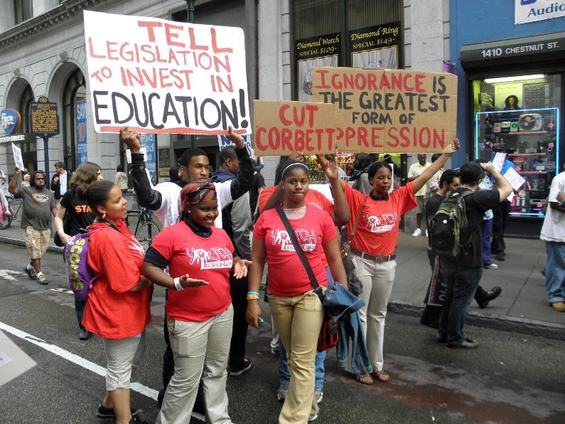
Picture of student activists from Youth United for Change protesting education budget cuts. Image taken from the YUC Facebook page December 5th, 2019. https://www.facebook.com/Youth-United-for-Change-139373152779265/
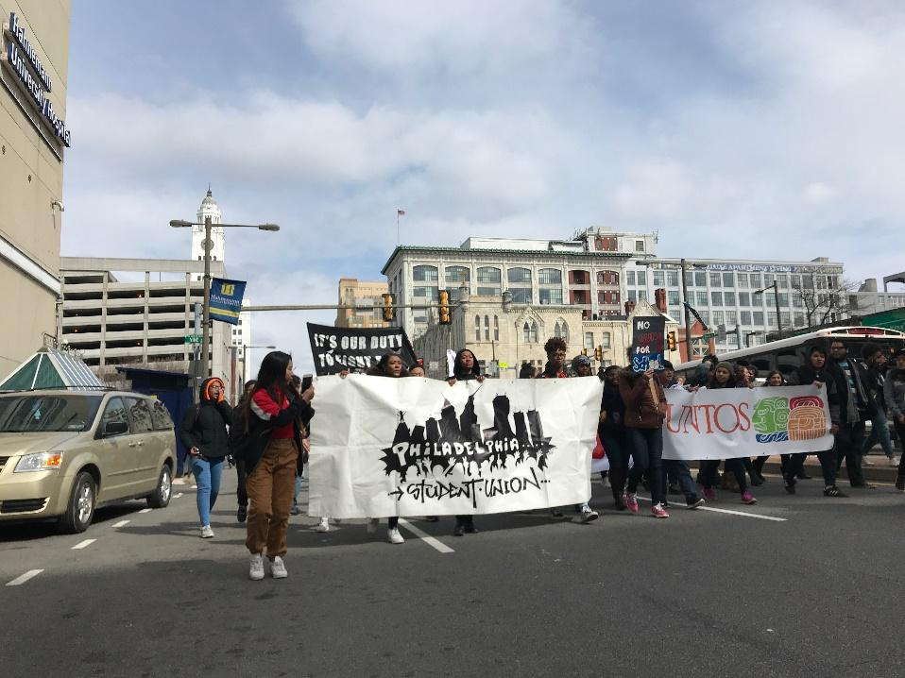
Image of PSU students protesting in Philly. Image taken from Philly Student Union website December 5th, 2019 https://phillystudentunion.org/history/

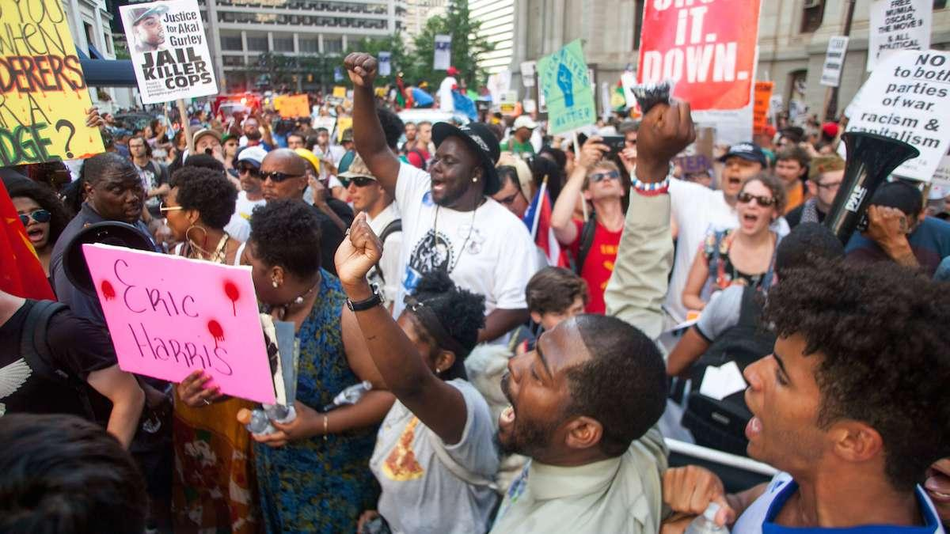 Demonstrators with a Black Lives Matter protest shout as they arrive at City Hall. (Brad Larrison for NewsWorks)

DECEMBER 2014–2016 BLACK LIVES MATTER
Although the Black Lives Matter movement began with the 2012 slaying of teenager Trayvon Martin in Florida, it quickly spread to other cities – including Philadelphia, where early Black Lives Matter actions targeted police brutality and criminal injustice. When a police officer gunned down Brandon Tate Brown during a routine traffic stop in Frankford, critics marched weekly for months to call for a federal investigation into his death. Activists here also rallied around a federal Justice Department study in March 2015 that found that police-involved shootings had risen even as crime overall dropped, cementing long standing distrust in the community.

Youth Activism in Washington, DC

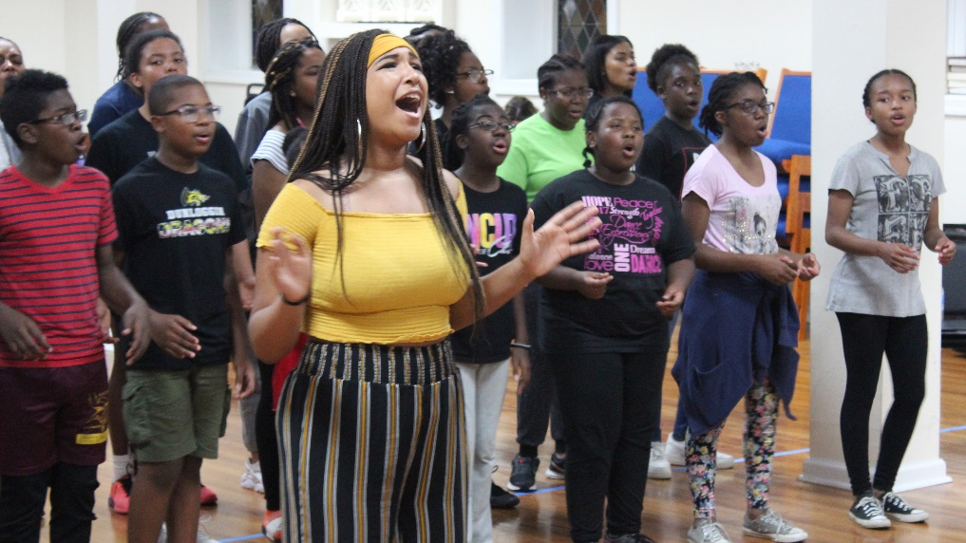
Sixteen-year-old Avery Johnson practices with the Children of the Gospel choir for a special performance themed around social justice. They named the program “Stay Woke, Still Woke.” Mikaela Lefrak / WAMU
The Young Woke Vote by Mikaela Lefrak WAMU
On a recent night at a church in D.C.’s Shaw neighborhood, members of the Washington Performing Arts Children of the Gospel choir rehearsed a special program called “Stay Woke, Still Woke.” The performance featured songs related to black culture and social justice, including African American spirituals and a step performance. Choir members like Stephanie Crawford, 17, of Bowie, Maryland, were involved in every facet of the show’s design. “This program is kind of a reflection of Black Lives Matter, Me Too, and the March for Our Lives, all this, you know, started in this kind of time,” Crawford said. “It’s not a time to just cower and not speak up. You just can’t let that initial moment just die away. “Crawford said she became an activist her freshman year of high school, after Freddie Gray’s death in Baltimore. This year she participated in a walkout at her school and went to the March for Our Lives with her godmother.
WAMU 88.5 American University Radio, Mikaela Lefrak

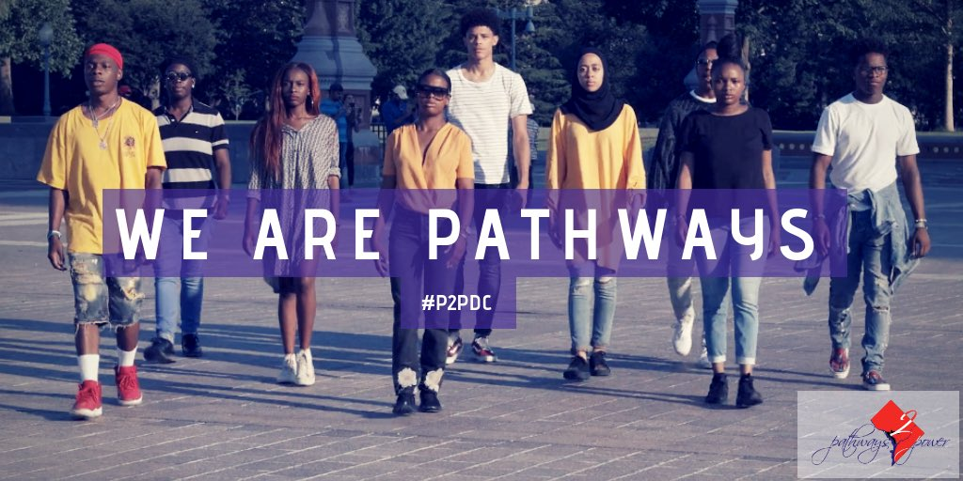

Downloaded from Pathways2power Instagram account Pathways 2 Power

@P2PDC January 6, 2020
Pathways 2 Power is a student-led activist group originated from Thurgood Marshall Academy, but inclusive of the city as a whole. We are starting conversations about issues going on in our backyard that have been normalized, including violence, crime, housing insecurity, mental health, and more. Our organization works to create a seat at the table in decision making that directly impacts our community. We are making change in our communities and finding ways to include our voices in the larger conversations in the city concerning violence. We are working to create a healthy community that lives up to the DC pride we have.
Downloaded from Pathways2Power website: https://www.pathways2power.org/what-we-do

Notes:

